**DB Lab 07**

**Name:** Hafsa Salman

**Roll no.** 22K-5161

**Lab Activity**

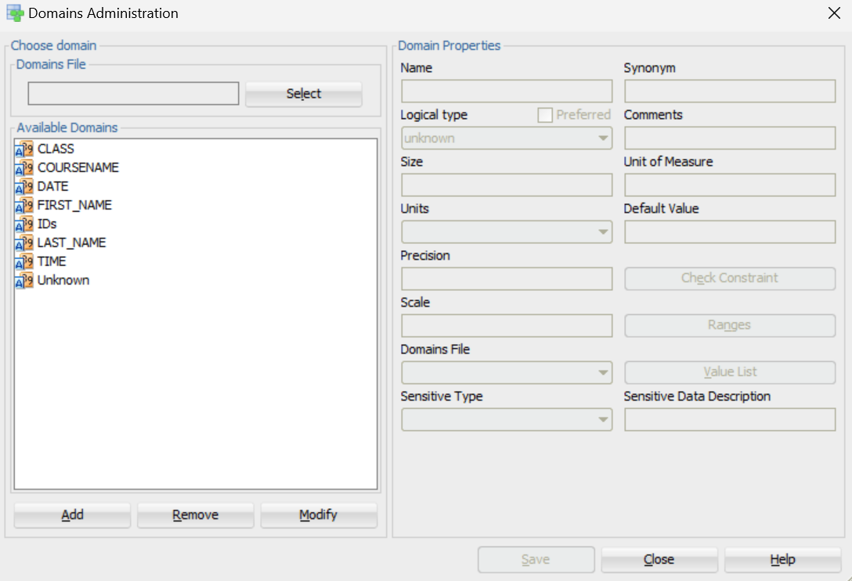

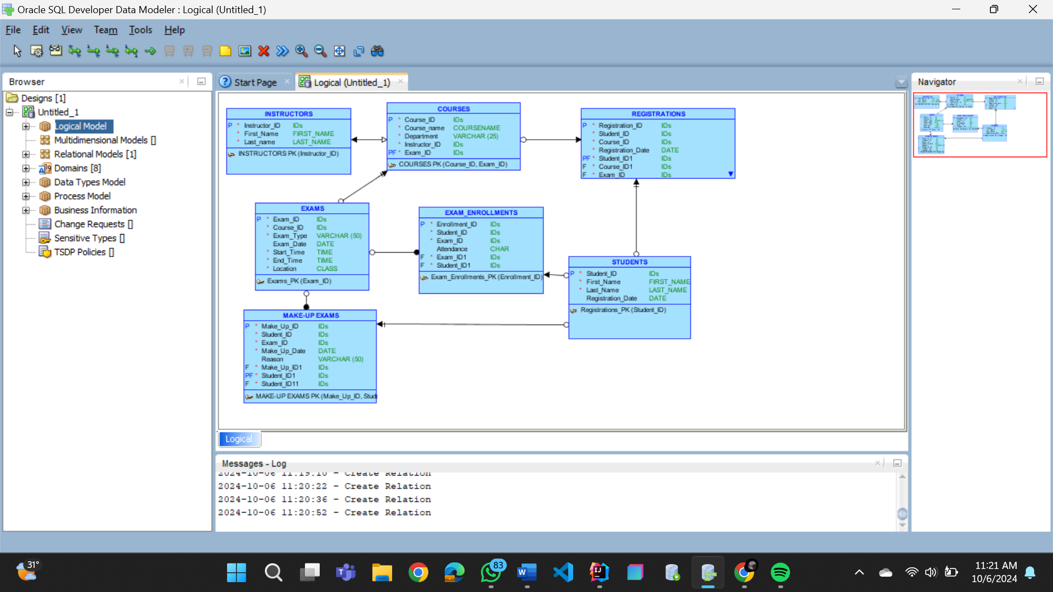

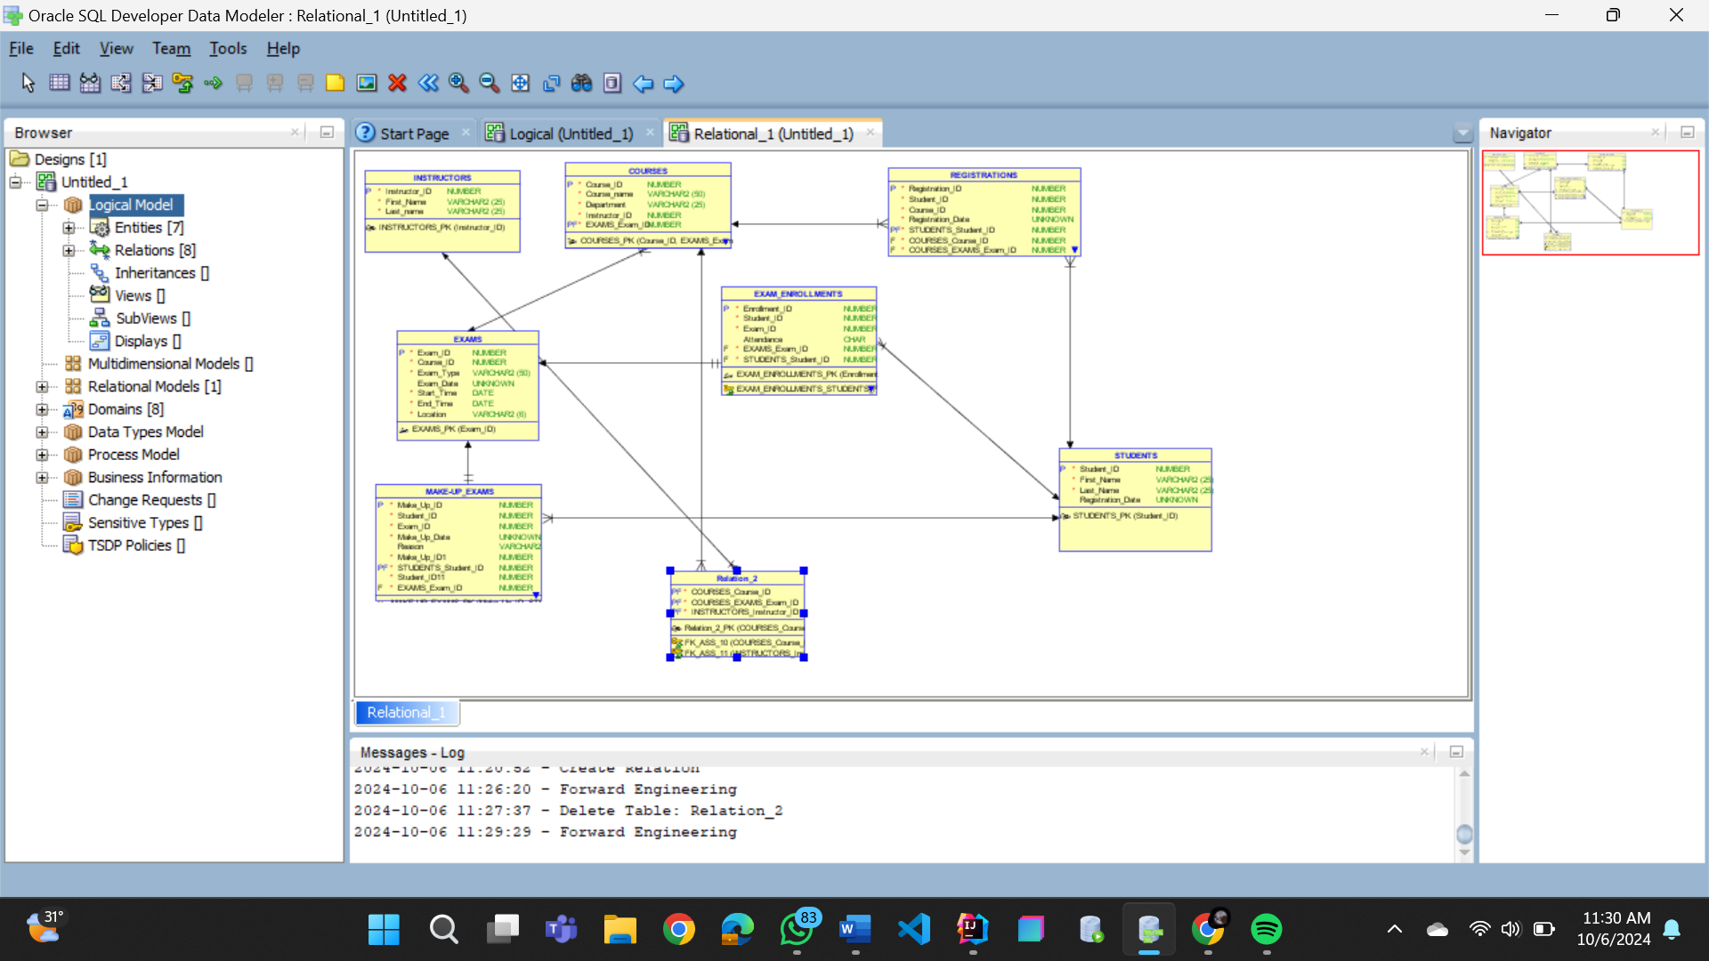

DDL:

-- Generated by Oracle SQL Developer Data Modeler 4.1.1.888

-- at: 2024-10-06 11:33:55 PKT

-- site: Oracle Database 11g

-- type: Oracle Database 11g

CREATE TABLE COURSES

(

Course_ID NUMBER NOT NULL ,

Course_name VARCHAR2 (50) NOT NULL ,

Department VARCHAR2 (25) NOT NULL ,

Instructor_ID NUMBER NOT NULL ,

EXAMS_Exam_ID NUMBER NOT NULL

) ;

-- WARNING: Column COURSES.Course_ID has no check constraint defined for this database type

-- WARNING: Column COURSES.Instructor_ID has no check constraint defined for this database type

-- WARNING: Column COURSES.EXAMS_Exam_ID has no check constraint defined for this database type

ALTER TABLE COURSES ADD CONSTRAINT COURSES_PK PRIMARY KEY ( Course_ID, EXAMS_Exam_ID ) ;

CREATE TABLE EXAMS

(

Exam_ID NUMBER NOT NULL ,

Course_ID NUMBER NOT NULL ,

Exam_Type VARCHAR2 (50) NOT NULL ,

Exam_Date UNKNOWN

-- ERROR: Datatype UNKNOWN is not allowed

,

Start_Time DATE NOT NULL ,

End_Time DATE NOT NULL ,

Location VARCHAR2 (6) NOT NULL

) ;

-- WARNING: Column EXAMS.Exam_ID has no check constraint defined for this database type

-- WARNING: Column EXAMS.Course_ID has no check constraint defined for this database type

ALTER TABLE EXAMS ADD CONSTRAINT EXAMS_PK PRIMARY KEY ( Exam_ID ) ;

CREATE TABLE EXAM_ENROLLMENTS

(

Enrollment_ID NUMBER NOT NULL ,

Student_ID NUMBER NOT NULL ,

Exam_ID NUMBER NOT NULL ,

Attendance CHAR

-- WARNING: CHAR size not specified

,

EXAMS_Exam_ID NUMBER NOT NULL ,

STUDENTS_Student_ID NUMBER NOT NULL

) ;

-- WARNING: Column EXAM_ENROLLMENTS.Enrollment_ID has no check constraint defined for this database type

-- WARNING: Column EXAM_ENROLLMENTS.Student_ID has no check constraint defined for this database type

-- WARNING: Column EXAM_ENROLLMENTS.Exam_ID has no check constraint defined for this database type

-- WARNING: Column EXAM_ENROLLMENTS.EXAMS_Exam_ID has no check constraint defined for this database type

-- WARNING: Column EXAM_ENROLLMENTS.STUDENTS_Student_ID has no check constraint defined for this database type

CREATE UNIQUE INDEX EXAM_ENROLLMENTS__IDX ON EXAM_ENROLLMENTS

(

EXAMS_Exam_ID ASC

)

;

ALTER TABLE EXAM_ENROLLMENTS ADD CONSTRAINT EXAM_ENROLLMENTS_PK PRIMARY KEY ( Enrollment_ID ) ;

CREATE TABLE INSTRUCTORS

(

Instructor_ID NUMBER NOT NULL ,

First_Name VARCHAR2 (25) NOT NULL ,

Last_name VARCHAR2 (25) NOT NULL

) ;

-- WARNING: Column INSTRUCTORS.Instructor_ID has no check constraint defined for this database type

ALTER TABLE INSTRUCTORS ADD CONSTRAINT INSTRUCTORS_PK PRIMARY KEY ( Instructor_ID ) ;

CREATE TABLE "MAKE-UP_EXAMS"

(

Make_Up_ID NUMBER NOT NULL ,

Student_ID NUMBER NOT NULL ,

Exam_ID NUMBER NOT NULL ,

Make_Up_Date UNKNOWN

-- ERROR: Datatype UNKNOWN is not allowed

NOT NULL ,

Reason VARCHAR2 (50) ,

Make_Up_ID1 NUMBER NOT NULL ,

STUDENTS_Student_ID NUMBER NOT NULL ,

Student_ID11 NUMBER NOT NULL ,

EXAMS_Exam_ID NUMBER NOT NULL

) ;

-- WARNING: Column MAKE-UP_EXAMS.Make_Up_ID has no check constraint defined for this database type

-- WARNING: Column MAKE-UP_EXAMS.Student_ID has no check constraint defined for this database type

-- WARNING: Column MAKE-UP_EXAMS.Exam_ID has no check constraint defined for this database type

-- WARNING: Column MAKE-UP_EXAMS.Make_Up_ID1 has no check constraint defined for this database type

-- WARNING: Column MAKE-UP_EXAMS.STUDENTS_Student_ID has no check constraint defined for this database type

-- WARNING: Column MAKE-UP_EXAMS.Student_ID11 has no check constraint defined for this database type

-- WARNING: Column MAKE-UP_EXAMS.EXAMS_Exam_ID has no check constraint defined for this database type

CREATE UNIQUE INDEX "MAKE-UP_EXAMS__IDX" ON "MAKE-UP_EXAMS"

(

EXAMS_Exam_ID ASC

)

;

ALTER TABLE "MAKE-UP_EXAMS" ADD CONSTRAINT "MAKE-UP_EXAMS_PK" PRIMARY KEY ( Make_Up_ID, STUDENTS_Student_ID ) ;

CREATE TABLE REGISTRATIONS

(

Registration_ID NUMBER NOT NULL ,

Student_ID NUMBER NOT NULL ,

Course_ID NUMBER NOT NULL ,

Registration_Date UNKNOWN

-- ERROR: Datatype UNKNOWN is not allowed

NOT NULL ,

STUDENTS_Student_ID NUMBER NOT NULL ,

COURSES_Course_ID NUMBER NOT NULL ,

COURSES_EXAMS_Exam_ID NUMBER NOT NULL

) ;

-- WARNING: Column REGISTRATIONS.Registration_ID has no check constraint defined for this database type

-- WARNING: Column REGISTRATIONS.Student_ID has no check constraint defined for this database type

-- WARNING: Column REGISTRATIONS.Course_ID has no check constraint defined for this database type

-- WARNING: Column REGISTRATIONS.STUDENTS_Student_ID has no check constraint defined for this database type

-- WARNING: Column REGISTRATIONS.COURSES_Course_ID has no check constraint defined for this database type

-- WARNING: Column REGISTRATIONS.COURSES_EXAMS_Exam_ID has no check constraint defined for this database type

ALTER TABLE REGISTRATIONS ADD CONSTRAINT REGISTRATIONS_PK PRIMARY KEY ( Registration_ID, STUDENTS_Student_ID ) ;

CREATE TABLE Relation_2

(

COURSES_Course_ID NUMBER NOT NULL ,

COURSES_EXAMS_Exam_ID NUMBER NOT NULL ,

INSTRUCTORS_Instructor_ID NUMBER NOT NULL

) ;

-- WARNING: Column Relation_2.COURSES_Course_ID has no check constraint defined for this database type

-- WARNING: Column Relation_2.COURSES_EXAMS_Exam_ID has no check constraint defined for this database type

-- WARNING: Column Relation_2.INSTRUCTORS_Instructor_ID has no check constraint defined for this database type

ALTER TABLE Relation_2 ADD CONSTRAINT Relation_2_PK PRIMARY KEY ( COURSES_Course_ID, COURSES_EXAMS_Exam_ID, INSTRUCTORS_Instructor_ID ) ;

CREATE TABLE STUDENTS

(

Student_ID NUMBER NOT NULL ,

First_Name VARCHAR2 (25) NOT NULL ,

Last_Name VARCHAR2 (25) NOT NULL ,

Registration_Date UNKNOWN

-- ERROR: Datatype UNKNOWN is not allowed

) ;

-- WARNING: Column STUDENTS.Student_ID has no check constraint defined for this database type

ALTER TABLE STUDENTS ADD CONSTRAINT STUDENTS_PK PRIMARY KEY ( Student_ID ) ;

ALTER TABLE COURSES ADD CONSTRAINT COURSES_EXAMS_FK FOREIGN KEY ( EXAMS_Exam_ID ) REFERENCES EXAMS ( Exam_ID ) ;

ALTER TABLE EXAM_ENROLLMENTS ADD CONSTRAINT EXAM_ENROLLMENTS_EXAMS_FK FOREIGN KEY ( EXAMS_Exam_ID ) REFERENCES EXAMS ( Exam_ID ) ;

ALTER TABLE EXAM_ENROLLMENTS ADD CONSTRAINT EXAM_ENROLLMENTS_STUDENTS_FK FOREIGN KEY ( STUDENTS_Student_ID ) REFERENCES STUDENTS ( Student_ID ) ;

ALTER TABLE Relation_2 ADD CONSTRAINT FK_ASS_10 FOREIGN KEY ( COURSES_Course_ID, COURSES_EXAMS_Exam_ID ) REFERENCES COURSES ( Course_ID, EXAMS_Exam_ID ) ;

ALTER TABLE Relation_2 ADD CONSTRAINT FK_ASS_11 FOREIGN KEY ( INSTRUCTORS_Instructor_ID ) REFERENCES INSTRUCTORS ( Instructor_ID ) ;

ALTER TABLE "MAKE-UP_EXAMS" ADD CONSTRAINT "MAKE-UP_EXAMS_EXAMS_FK" FOREIGN KEY ( EXAMS_Exam_ID ) REFERENCES EXAMS ( Exam_ID ) ;

ALTER TABLE "MAKE-UP_EXAMS" ADD CONSTRAINT "MAKE-UP_EXAMS_STUDENTS_FK" FOREIGN KEY ( STUDENTS_Student_ID ) REFERENCES STUDENTS ( Student_ID ) ;

ALTER TABLE REGISTRATIONS ADD CONSTRAINT REGISTRATIONS_COURSES_FK FOREIGN KEY ( COURSES_Course_ID, COURSES_EXAMS_Exam_ID ) REFERENCES COURSES ( Course_ID, EXAMS_Exam_ID ) ;

ALTER TABLE REGISTRATIONS ADD CONSTRAINT REGISTRATIONS_STUDENTS_FK FOREIGN KEY ( STUDENTS_Student_ID ) REFERENCES STUDENTS ( Student_ID ) ;

-- Oracle SQL Developer Data Modeler Summary Report:

--

-- CREATE TABLE 8

-- CREATE INDEX 2

-- ALTER TABLE 17

-- CREATE VIEW 0

-- ALTER VIEW 0

-- CREATE PACKAGE 0

-- CREATE PACKAGE BODY 0

-- CREATE PROCEDURE 0

-- CREATE FUNCTION 0

-- CREATE TRIGGER 0

-- ALTER TRIGGER 0

-- CREATE COLLECTION TYPE 0

-- CREATE STRUCTURED TYPE 0

-- CREATE STRUCTURED TYPE BODY 0

-- CREATE CLUSTER 0

-- CREATE CONTEXT 0

-- CREATE DATABASE 0

-- CREATE DIMENSION 0

-- CREATE DIRECTORY 0

-- CREATE DISK GROUP 0

-- CREATE ROLE 0

-- CREATE ROLLBACK SEGMENT 0

-- CREATE SEQUENCE 0

-- CREATE MATERIALIZED VIEW 0

-- CREATE SYNONYM 0

-- CREATE TABLESPACE 0

-- CREATE USER 0

--

-- DROP TABLESPACE 0

-- DROP DATABASE 0

--

-- REDACTION POLICY 0

--

-- ORDS DROP SCHEMA 0

-- ORDS ENABLE SCHEMA 0

-- ORDS ENABLE OBJECT 0

--

-- ERRORS 4

-- WARNINGS 29

**Lab Task**

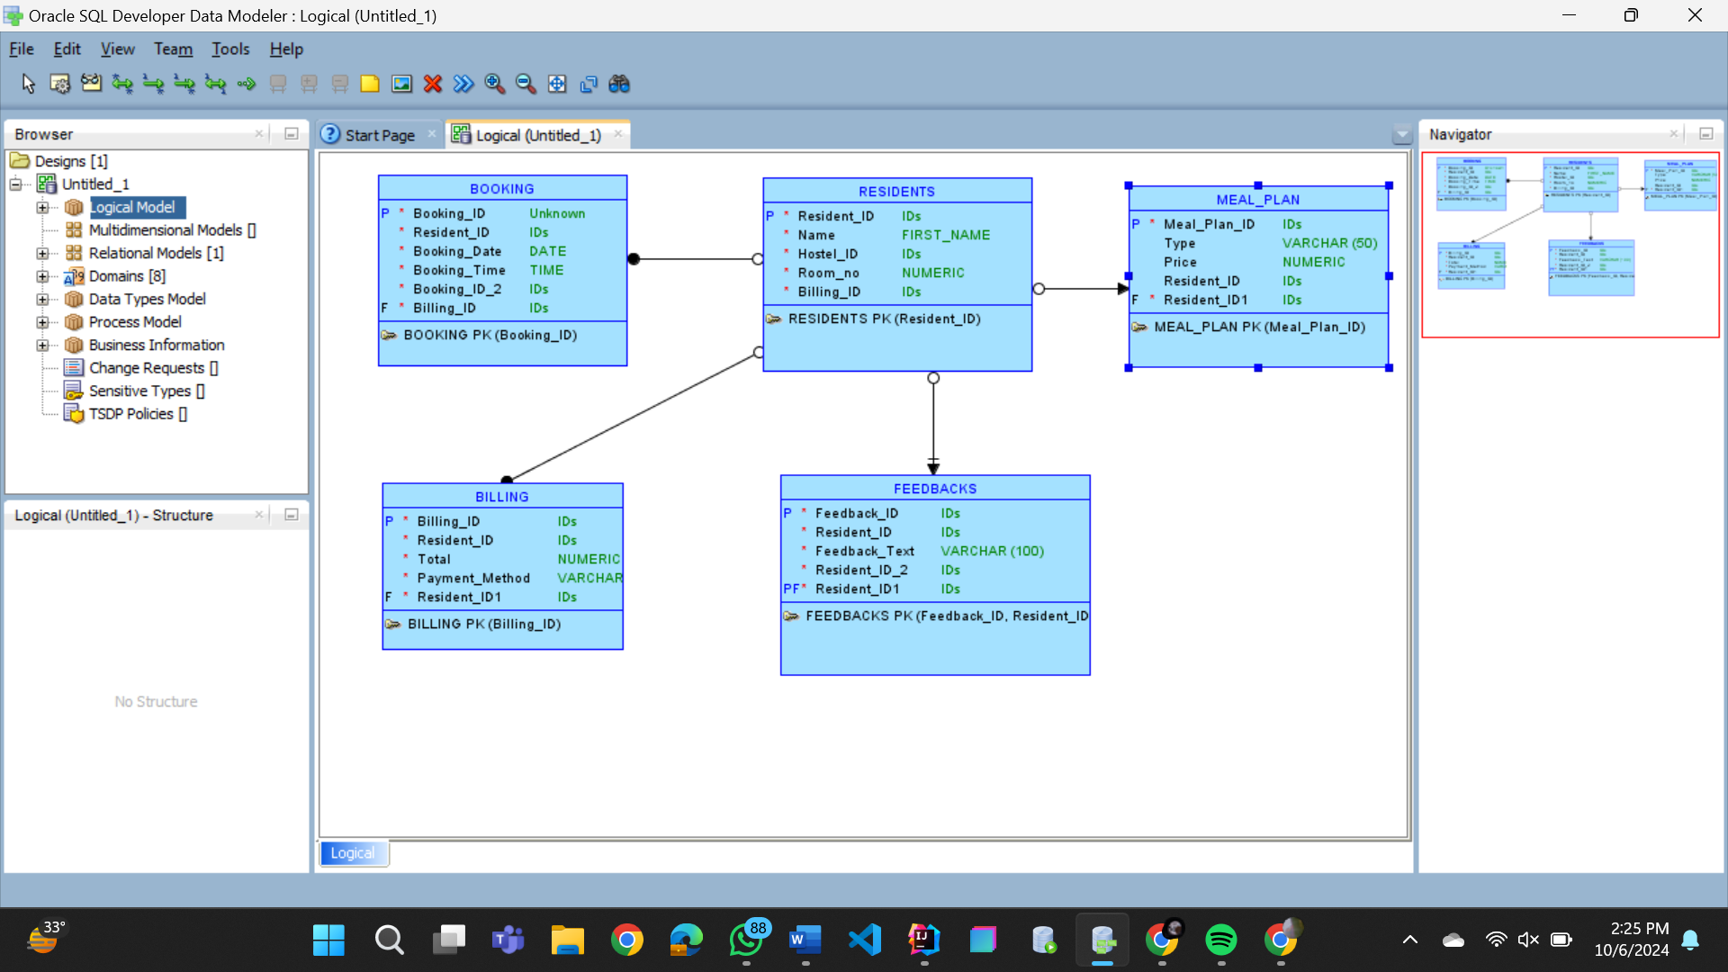

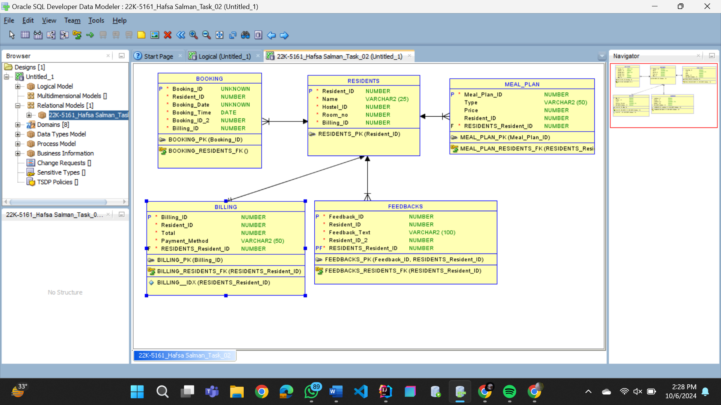

DDL:

-- Generated by Oracle SQL Developer Data Modeler 4.1.1.888

-- at: 2024-10-06 14:30:00 PKT

-- site: Oracle Database 11g

-- type: Oracle Database 11g

CREATE TABLE BILLING

(

Billing_ID NUMBER NOT NULL ,

Resident_ID NUMBER NOT NULL ,

Total NUMBER NOT NULL ,

Payment_Method VARCHAR2 (50) NOT NULL ,

RESIDENTS_Resident_ID NUMBER NOT NULL

) ;

CREATE UNIQUE INDEX BILLING__IDX ON BILLING

(

RESIDENTS_Resident_ID ASC

)

;

ALTER TABLE BILLING ADD CONSTRAINT BILLING_PK PRIMARY KEY ( Billing_ID ) ;

CREATE TABLE BOOKING

(

Booking_ID UNKNOWN

-- ERROR: Datatype UNKNOWN is not allowed

NOT NULL ,

Resident_ID NUMBER NOT NULL ,

Booking_Date UNKNOWN

-- ERROR: Datatype UNKNOWN is not allowed

NOT NULL ,

Booking_Time DATE NOT NULL ,

Booking_ID_2 NUMBER NOT NULL ,

Billing_ID NUMBER NOT NULL

) ;

ALTER TABLE BOOKING ADD CONSTRAINT BOOKING_PK PRIMARY KEY ( Booking_ID ) ;

CREATE TABLE FEEDBACKS

(

Feedback_ID NUMBER NOT NULL ,

Resident_ID NUMBER NOT NULL ,

Feedback_Text VARCHAR2 (100) NOT NULL ,

Resident_ID_2 NUMBER NOT NULL ,

RESIDENTS_Resident_ID NUMBER NOT NULL

) ;

ALTER TABLE FEEDBACKS ADD CONSTRAINT FEEDBACKS_PK PRIMARY KEY ( Feedback_ID, RESIDENTS_Resident_ID ) ;

CREATE TABLE MEAL_PLAN

(

Meal_Plan_ID NUMBER NOT NULL ,

Type VARCHAR2 (50) ,

Price NUMBER ,

Resident_ID NUMBER ,

RESIDENTS_Resident_ID NUMBER NOT NULL

) ;

ALTER TABLE MEAL_PLAN ADD CONSTRAINT MEAL_PLAN_PK PRIMARY KEY ( Meal_Plan_ID ) ;

CREATE TABLE RESIDENTS

(

Resident_ID NUMBER NOT NULL ,

Name VARCHAR2 (25) NOT NULL ,

Hostel_ID NUMBER NOT NULL ,

Room_no NUMBER NOT NULL ,

Billing_ID NUMBER NOT NULL

) ;

ALTER TABLE RESIDENTS ADD CONSTRAINT RESIDENTS_PK PRIMARY KEY ( Resident_ID ) ;

ALTER TABLE BILLING ADD CONSTRAINT BILLING_RESIDENTS_FK FOREIGN KEY ( RESIDENTS_Resident_ID ) REFERENCES RESIDENTS ( Resident_ID ) ;

-- Error - Foreign Key BOOKING_RESIDENTS_FK has no columns

ALTER TABLE FEEDBACKS ADD CONSTRAINT FEEDBACKS_RESIDENTS_FK FOREIGN KEY ( RESIDENTS_Resident_ID ) REFERENCES RESIDENTS ( Resident_ID ) ;

ALTER TABLE MEAL_PLAN ADD CONSTRAINT MEAL_PLAN_RESIDENTS_FK FOREIGN KEY ( RESIDENTS_Resident_ID ) REFERENCES RESIDENTS ( Resident_ID ) ;

-- Oracle SQL Developer Data Modeler Summary Report:

--

-- CREATE TABLE 5

-- CREATE INDEX 1

-- ALTER TABLE 8

-- CREATE VIEW 0

-- ALTER VIEW 0

-- CREATE PACKAGE 0

-- CREATE PACKAGE BODY 0

-- CREATE PROCEDURE 0

-- CREATE FUNCTION 0

-- CREATE TRIGGER 0

-- ALTER TRIGGER 0

-- CREATE COLLECTION TYPE 0

-- CREATE STRUCTURED TYPE 0

-- CREATE STRUCTURED TYPE BODY 0

-- CREATE CLUSTER 0

-- CREATE CONTEXT 0

-- CREATE DATABASE 0

-- CREATE DIMENSION 0

-- CREATE DIRECTORY 0

-- CREATE DISK GROUP 0

-- CREATE ROLE 0

-- CREATE ROLLBACK SEGMENT 0

-- CREATE SEQUENCE 0

-- CREATE MATERIALIZED VIEW 0

-- CREATE SYNONYM 0

-- CREATE TABLESPACE 0

-- CREATE USER 0

--

-- DROP TABLESPACE 0

-- DROP DATABASE 0

--

-- REDACTION POLICY 0

--

-- ORDS DROP SCHEMA 0

-- ORDS ENABLE SCHEMA 0

-- ORDS ENABLE OBJECT 0

--

-- ERRORS 3

-- WARNINGS 0